**ATLANTA POPULATION**

1. MongoDB Enterprise atlas-z8cl0o-shard-0:PRIMARY>

**db.zipcodes.find({city:"ATLANTA",state:"GA"}).pretty()**

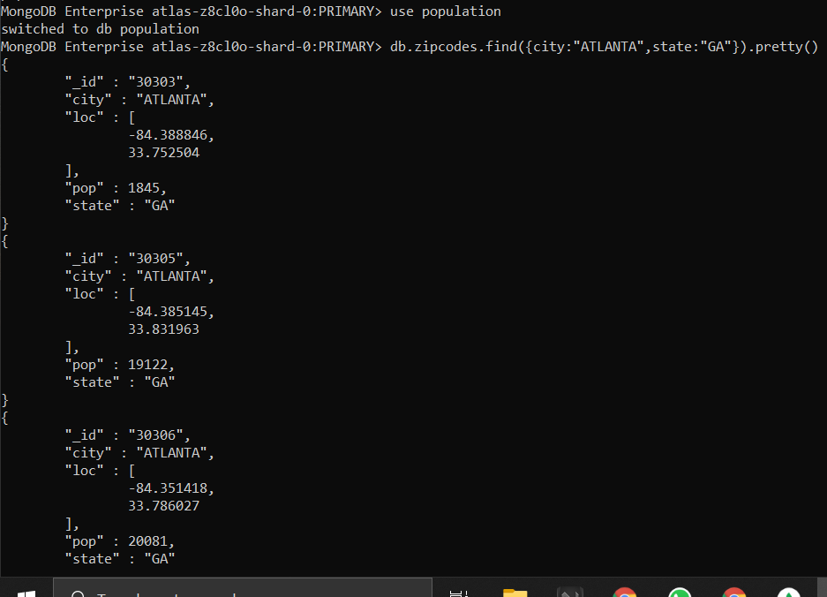

1. MongoDB Enterpriseatlas-z8cl0o-shard-0:PRIMARY>

**db.zipcodes.aggregate([{$match:{$and:[{city:"ATLANTA"},{state:"GA"}]}}]).pretty()**

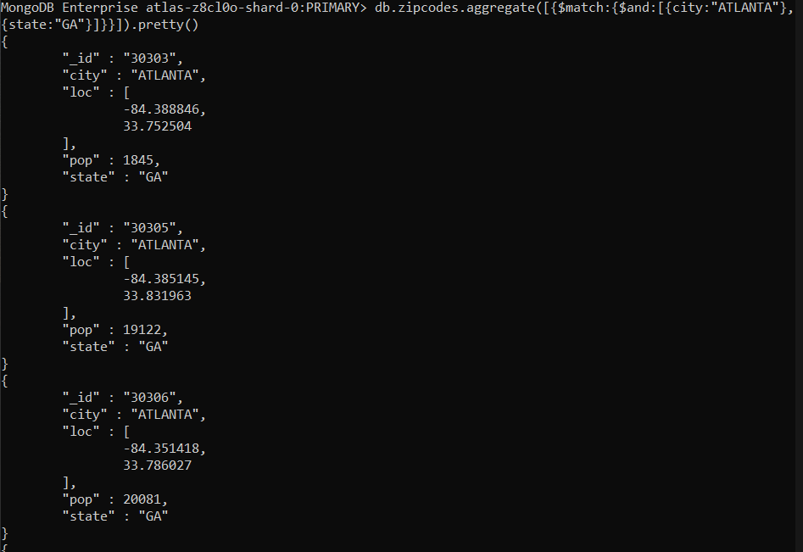

3] MongoDB Enterprise atlas-z8cl0o-shard-0:PRIMARY>

**db.zipcodes.aggregate([ {$match: {city:"ATLANTA"} }, {$group:{ _id:"$city",zipcodes:{$sum:1}}}])**

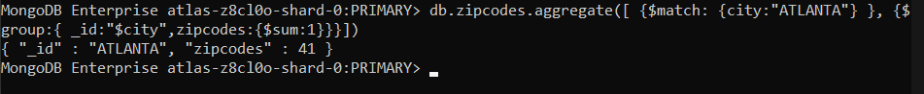

4 MongoDB Enterprise atlas-z8cl0o-shard-0:PRIMARY>

**db.zipcodes.aggregate([ {$match: {city:"ATLANTA"} }, {$group:{ _id:"$city", total_pop:{$sum:"$pop"}}}])**



**POPULATION BY STATE**

1]MongoDB Enterprise atlas-z8cl0o-shard-0:PRIMARY>

**db.zipcodes.aggregate([{$group:{_id:"$state",totalPop:{sum:"$pop"}}}])**

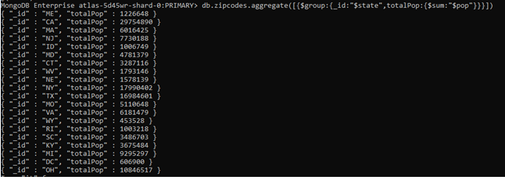

2] 3]

MongoDB Enterprise atlas-z8cl0o-shard-0:PRIMARY>

**db.zipcodes.aggregate([{$group:{_id:"$state",totalpop:{$sum:"$pop"}}},{$sort:{totalpop:-1}},{$limit:3}])**

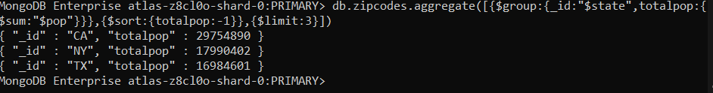

**POPULATION BY CITY**

1] MongoDB Enterprise atlas-z8cl0o-shard-0:PRIMARY>

**db.zipcodes.aggregate([{$group:{_id:{city:"$city",state:"$state"},totalPop:{$sum:"$pop"}}}])**

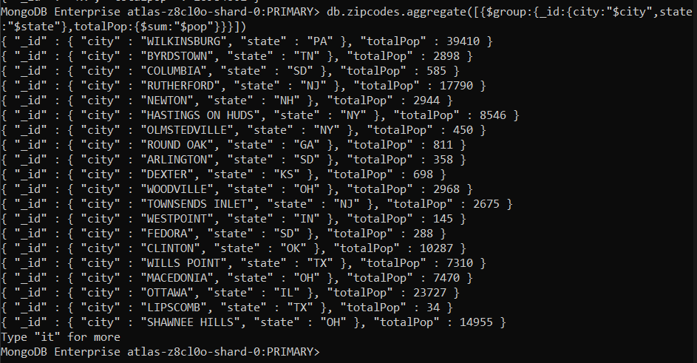

2] 3] 4]

MongoDB Enterprise atlas-z8cl0o-shard-0:PRIMARY> **db.zipcodes.aggregate([{$group:{state:"TX",city:"$city"},citypop:{$sum:"$pop"}}},{$sort:{totalpop:-1}},{$limit:3}])**

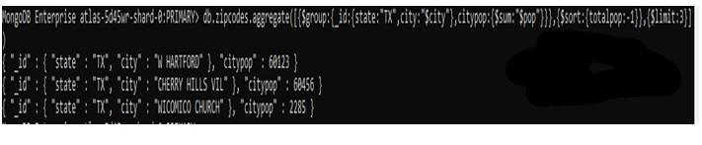

**BONUS**

1]

MongoDB Enterprise atlas-z8cl0o-shard-0:PRIMARY>

**db.zipcodes.aggregate( [**

**... ... { $group: { _id: { state: "$state", city: "$city" }, pop: { $sum: "$pop" } } },**

**... ... { $group: { _id: "$_id.state", avgCityPop: { $avg: "$pop" } } }**

**... ... ] )**

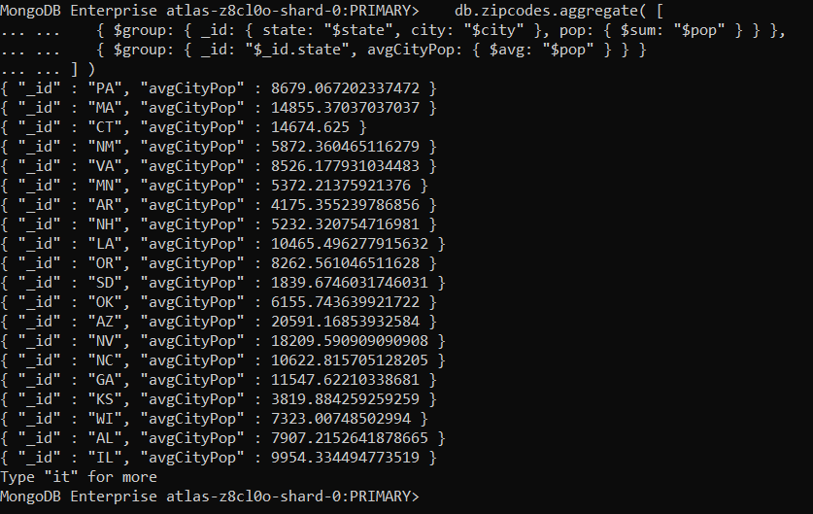

2] MongoDB Enterprise atlas-z8cl0o-shard-0:PRIMARY>

**db.zipcodes.aggregate( [ { $group: { _id: { state: "$state", city: "$city" }, pop: { $sum: "$pop" } } }, { $group: { _id: "$_id.state", avgCityPop: { $avg: "$pop" } }},{$limit:3} ] )**

